**Designing The RemoveReceptionistFrame**

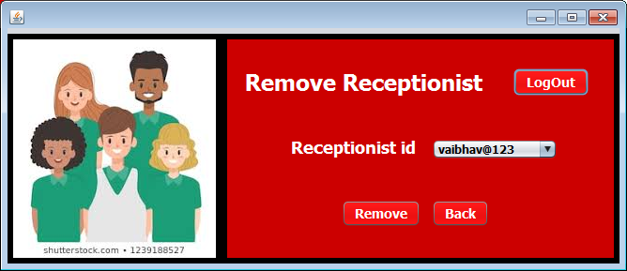

**STEPS TO BE DONE IN** **RemoveReceptionistFrame**

In the **RemoveReceptionistFrame** we need to do following steps:

1. Allow the user to **logout**
2. Handle the Constructor

**Displaying The Username**

Same as **AdminOptionsFrame**

**Allowing The User To Logout**

Same as **AdminOptionsFrame**

**Handling The Constructor**

The next task is to Fetch all the present receptionists present in the **users table** and to display all the **userids** of the Receptionists in the jComboBox. To do this we need to following Steps:

1. **We have to create a method getAllreceptionistIds() in ReceptionistDao and it will return an HashSet of all the ids.**

**Prototype-**

***public static HashSet<String> getReceptionistId() throws SQLException***